Blue Wrap Bag Directions

Makes 2 Bags

Supplies
1 44x44 Blue Wrap (straps)
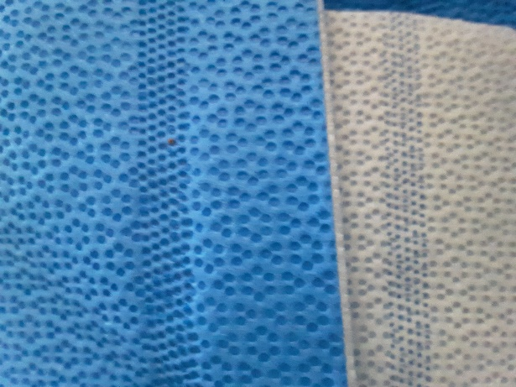
1 44x44 or 36x36 Blue Wrap (Bag)
Sewing Machine
Demin or Heavy duty sewing machine needle
Thread
Rotary Cutter, ruler and mat
Paper Clips
RIGHT SIDE = Blue
Right Side Wrong side
WRONG SIDE = White

STRAPS

From 44x44 piece of blue wrap cut 2 pieces 4” by 44” | 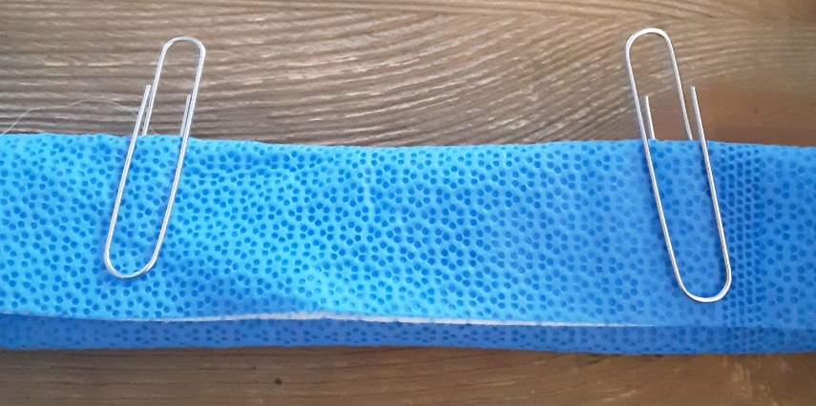
Fold into thirds {white on the inside} and use paper clips to secure.

Use wide Zig zag stitch and sew down the center of the strip, removing paper clips as you go.  Add side stitching if you like | 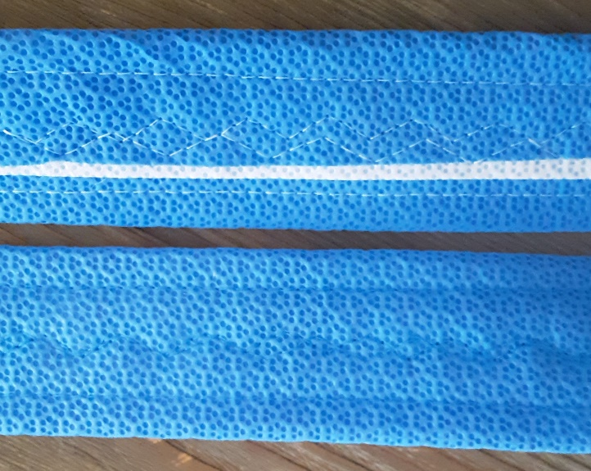
Cut finished straps in half, giving you 4- 22” straps.

BAG

Blue wrap has an open side and a closed side (selvage).  Cut either 36x36 or 44x44 blue wrap in half, so the selvage is on the short end.  Create hem by folding over the short ends over twice towards the inside (white) of the bag, secure with paper clips. | 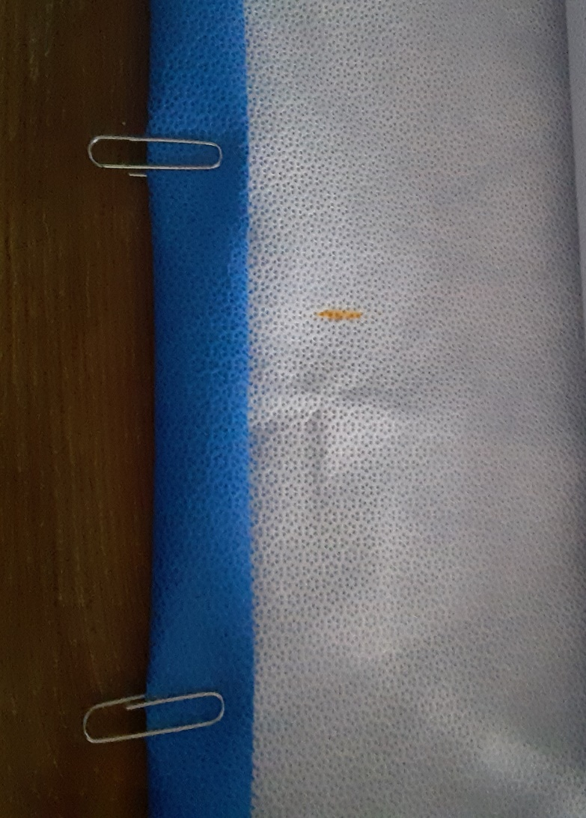  Mark for handle placement
Handle placement – On the white side of the bag by the hem mark for handle placement, For small bag mark at 4” from the edge, For large bag mark at 6” from the edge.  Handles are placed on the inside of the marks as shown here. | 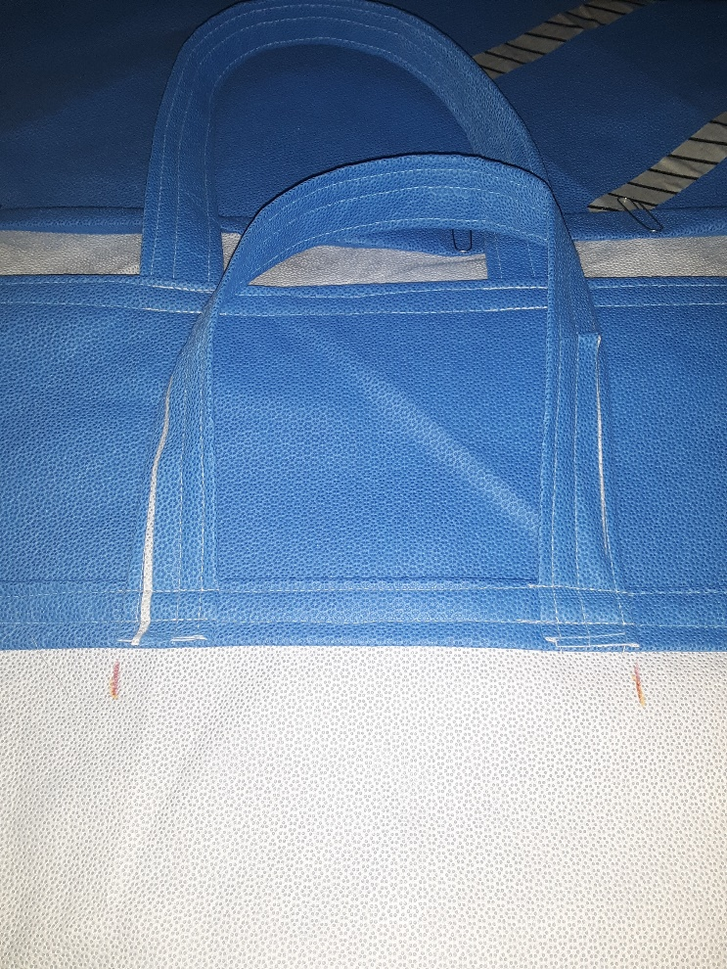
ASSEMBLY  Sew the hem of the bag (about ¼” from edge) attach handles at 4” or 6”, Back stitch to anchor handles.  Repeat below first hem. | 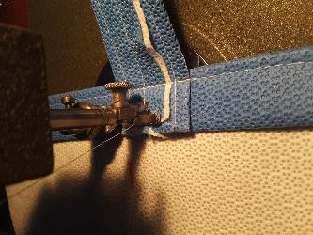
With right sides together (blue) sew down the sides.  Trim threads and right side out bag.  Congrats!  You made a Blue Wrap Bag! | 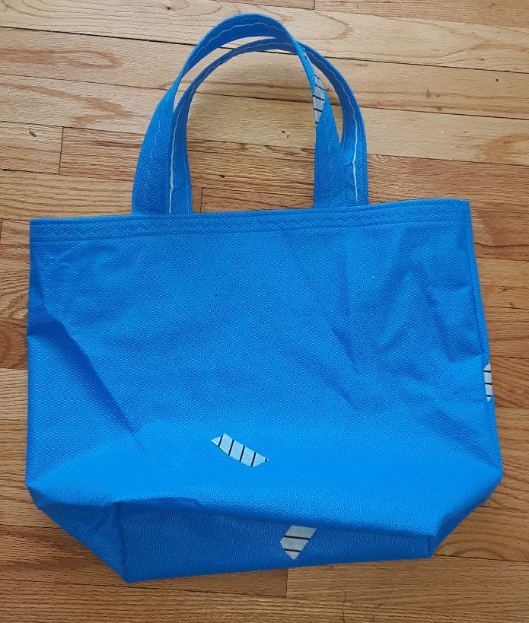
Questions tamara.ochs@atlantichealth.org

