N95 Sterilization Process

In accordance with system and CDC guidelines, BUMC is now sterilizing N95 masks daily using Bioquell equipment

What is Bioquell
- A method of disinfecting an N95 mask using hydrogen peroxide vapor
- This process is an alternative to placing the mask in the bag for five days and allows you to disinfect each mask up to 20 times

Why are we using Bioquell
- Over the past few weeks, we have fit tested over 2,000 caregivers and distributed multiple N95 masks to those who require them
- Bioquell allows us to extend the life of our N95 masks while keeping our caregivers safe

What is the Process

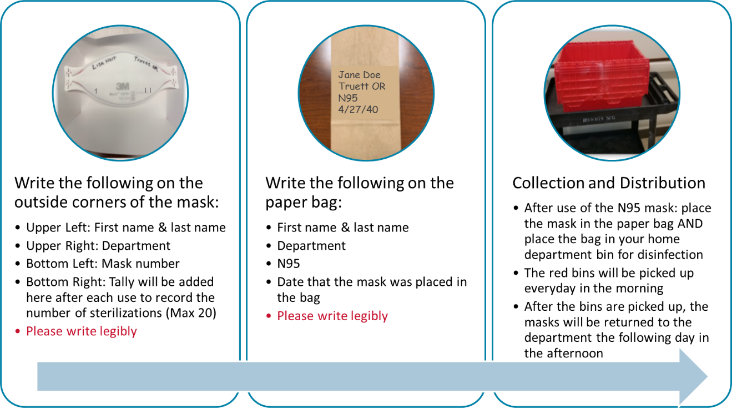

- While the process of disinfecting takes approximately 24 hours, due to the pick-up and drop off times, a staff member may not get their mask back by their next shift. If the staff member has at least three N95 masks, they will always have enough to cycle through this process.

Updates as of 5/5/20
- Used/dirty N95 masks should be placed in the home department bin (department listed on the mask)
- Weekday Instructions: Red bin pick up will start at 8am (Monday - Friday)
- Weekend Instructions: ALL departments should send a representative to drop off their masks (in a red bin or clear bag) to 1st Floor Pickens Conference Room 1 by 8AM

